21L-5373 21L-7512 21L-1868

**Cyber Security**

**Assignment no 4**

**Analyzing Network Traffic**

**Activity no 1:**

**Captured Traffic:**

Showing all the traffic captured while doing web browsing and other activities required a local area network connection.

Protocols like UDP, TCP, QUIC, TLS etc. used.

UDP facilitates real-time applications and DNS queries, TCP ensures reliable communication, QUIC enhances web performance, and TLS secures data, collectively ensuring seamless and secure internet interactions.

**Screenshots Attached:**

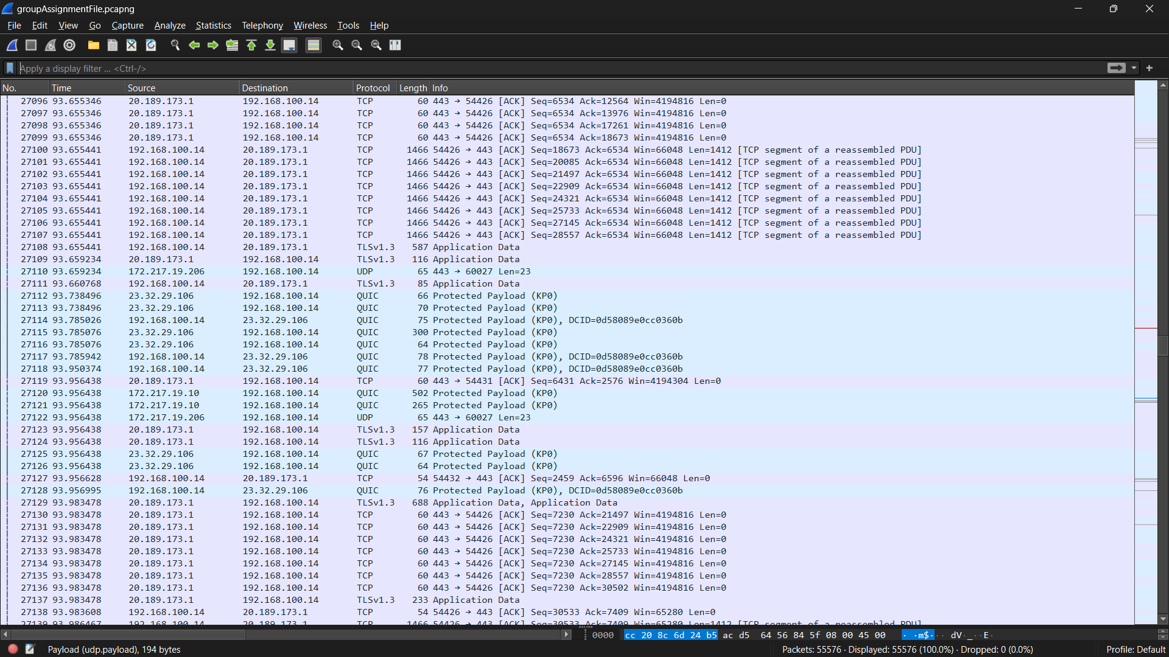

**Activity no 2:**

**QUIC**, a protocol favored by Google for its speed and security advantages, is extensively utilized in web browsing. To review all captured protocol data in **Wireshark**, apply the "filetype" filter. This simple step allows a thorough examination of QUIC's influence on network traffic, illustrating its role in enhancing browsing speed and safeguarding online activities. By utilizing the "filetype" filter in Wireshark analysis, one can effectively showcase QUIC's significance in optimizing browsing experiences and ensuring secure internet interactions.

**QUIC:** filter applied:

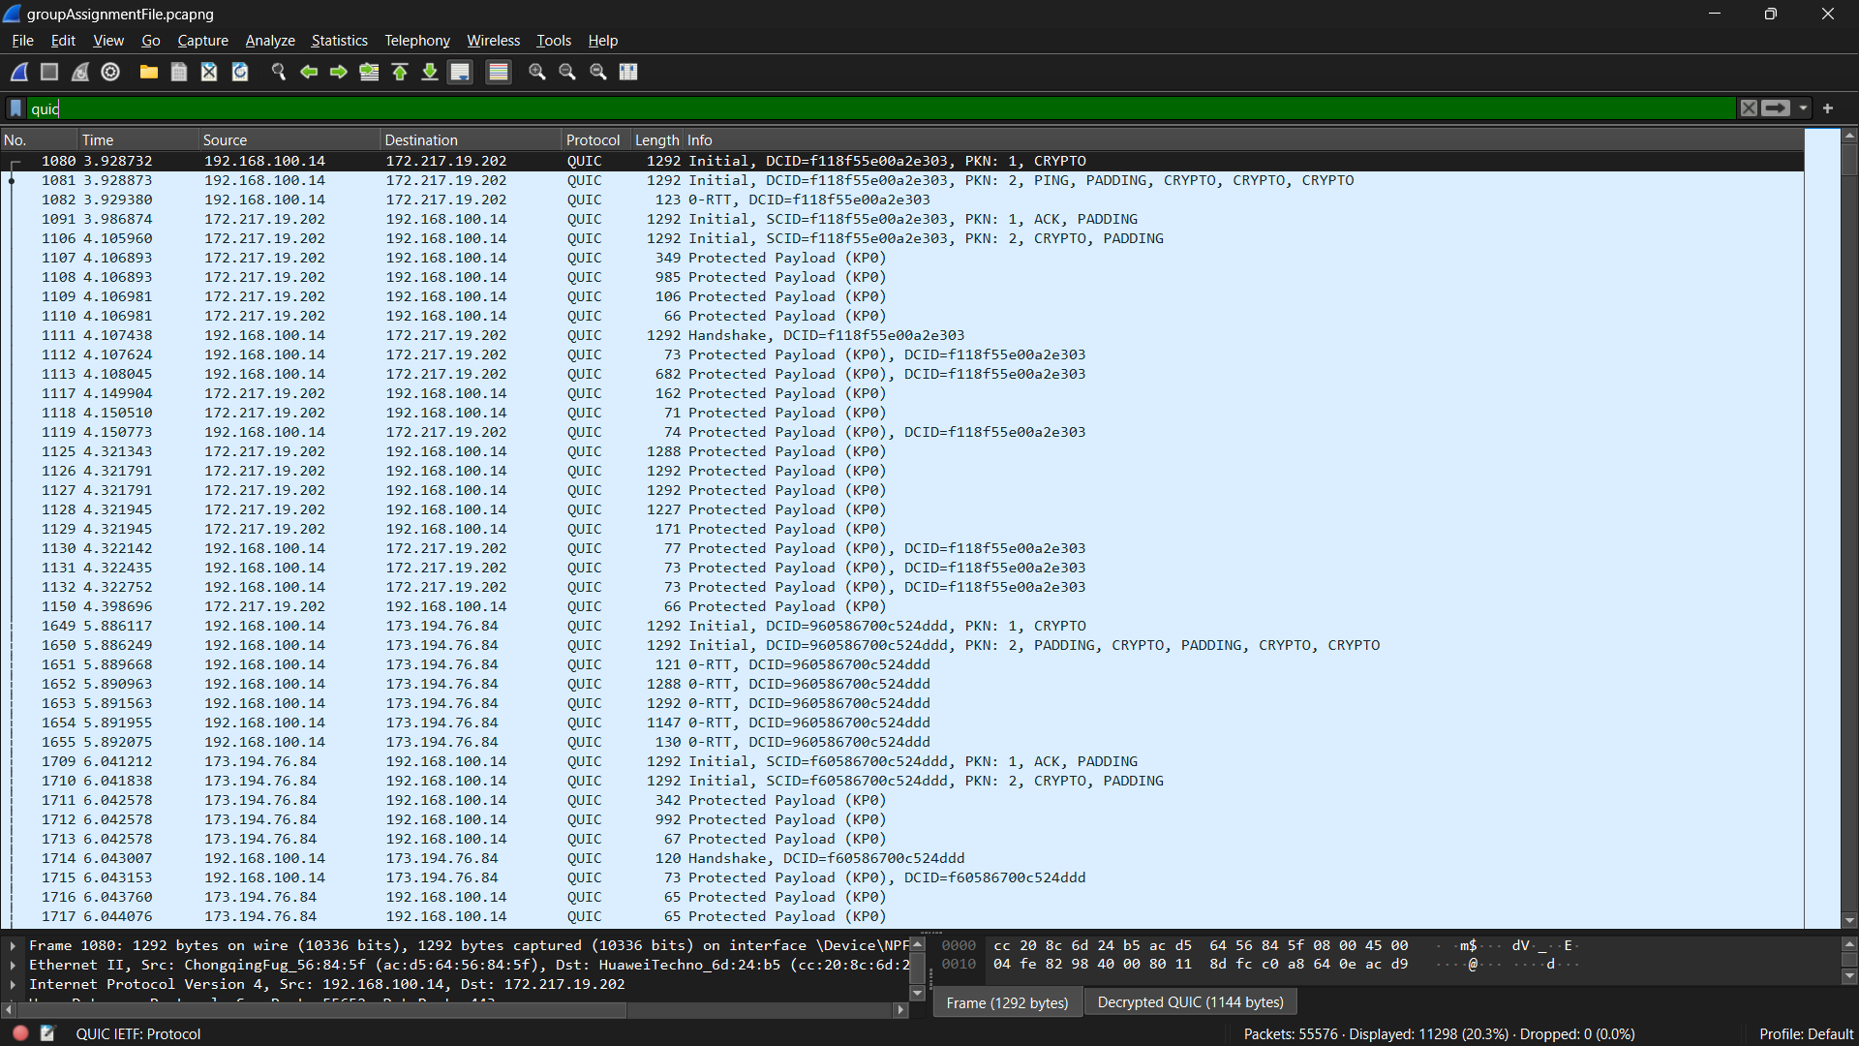

4

**Analyzing QUIC:**

Analyzing packet length, source, and destination related to QUIC protocol reveals insights into network efficiency and security. Studying these aspects helps understand data transmission patterns, origin, and destination, crucial for optimizing QUIC performance and ensuring secure communication, enhancing overall browsing experiences.

